**Las Vegas Documentation**

**Created by**

Natchanon Panthuwadeethorn 6231321021

Dragorn Padungpattanodom 6231323221

2110215 Programming Methodology Semester 2 Year 2019 Chulalongkorn University

**Las Vegas**

**Introduction**

Las Vegas is a famous board game. The objective of this game is to have most money in the game.

**How to play**

Each turn, you can select to roll the dice or use a skill. But, if you use skill, you can’t roll the dice. When you roll the dice, you have to select 1 number. Those dices with select number will go to the casino with the same number. When the round ends, each casino will distribute money. This game will calculate the winner in each casino by the number of player dices. The dices with highest amount without having the same as others win. If there are 2 or more dices have the same amount in casino. Those won’t get anything. Money will be add at the end of that round. At the start of round 2,3,4,5. You have to draw a skill card which is like event in that round. The game will end after 5 rounds.

**Example**

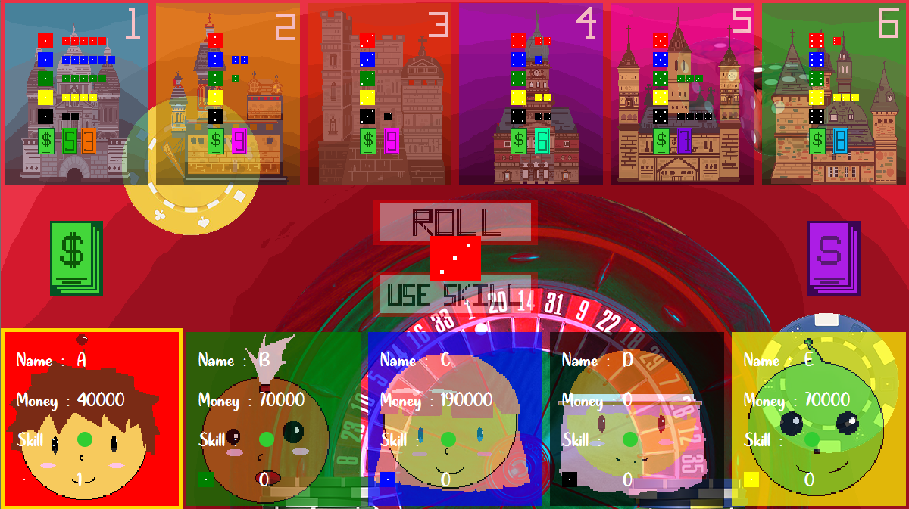

Round 1

Number 1 casino’s dice amount list is 5,6,5,4 and 2.Player that has 6 dices will win and get the first prize ($50,000). Player that has 4 dices will get the second prize ($30,000). Player that has 2 dices doesn’t get third prize because there are no third prize. And players with 5 dices won’t get anything.

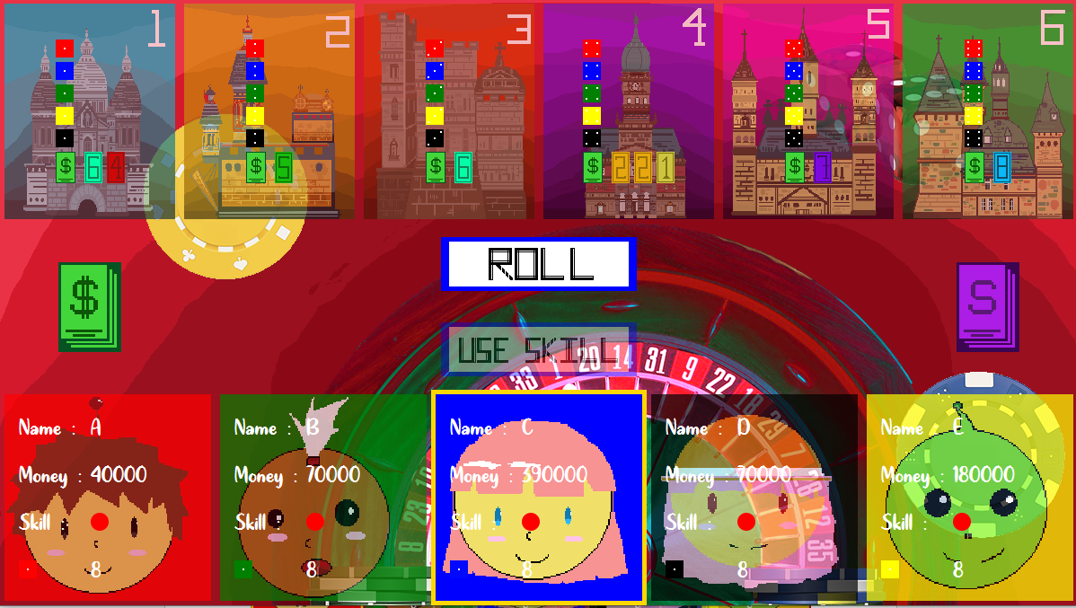

Round 2

**MainMenu Scene**

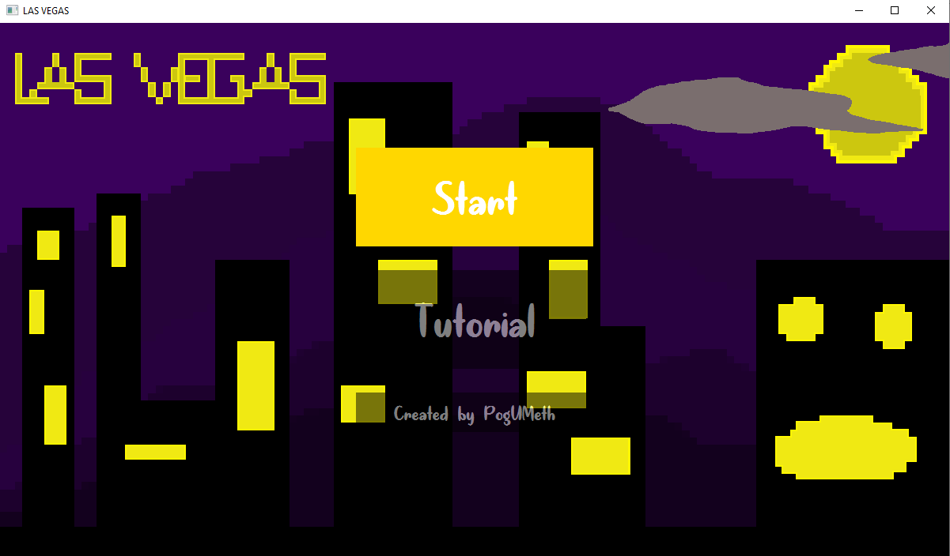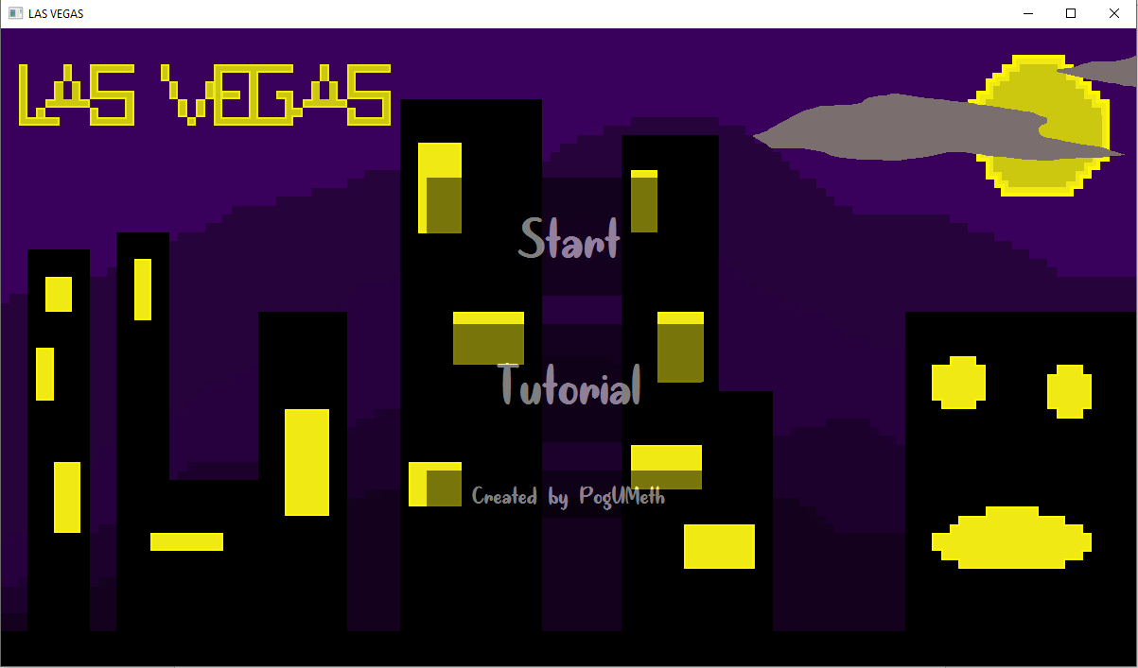You can tap start to enter the game

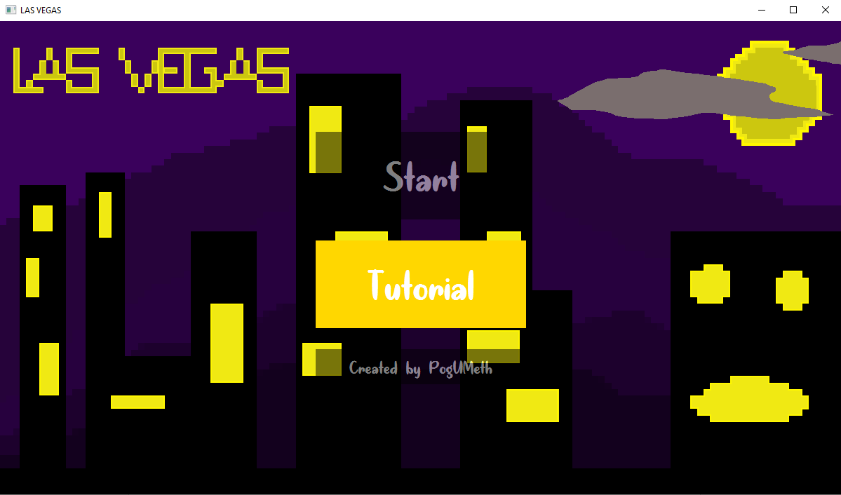You can tap tutorial. It will show you how to play.

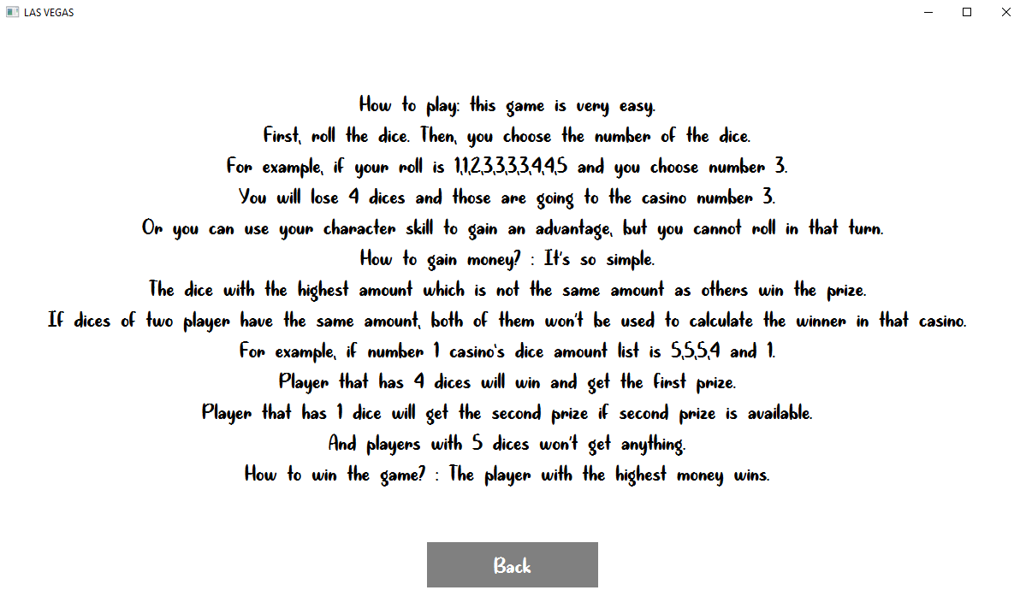

Tap back to go to main menu.

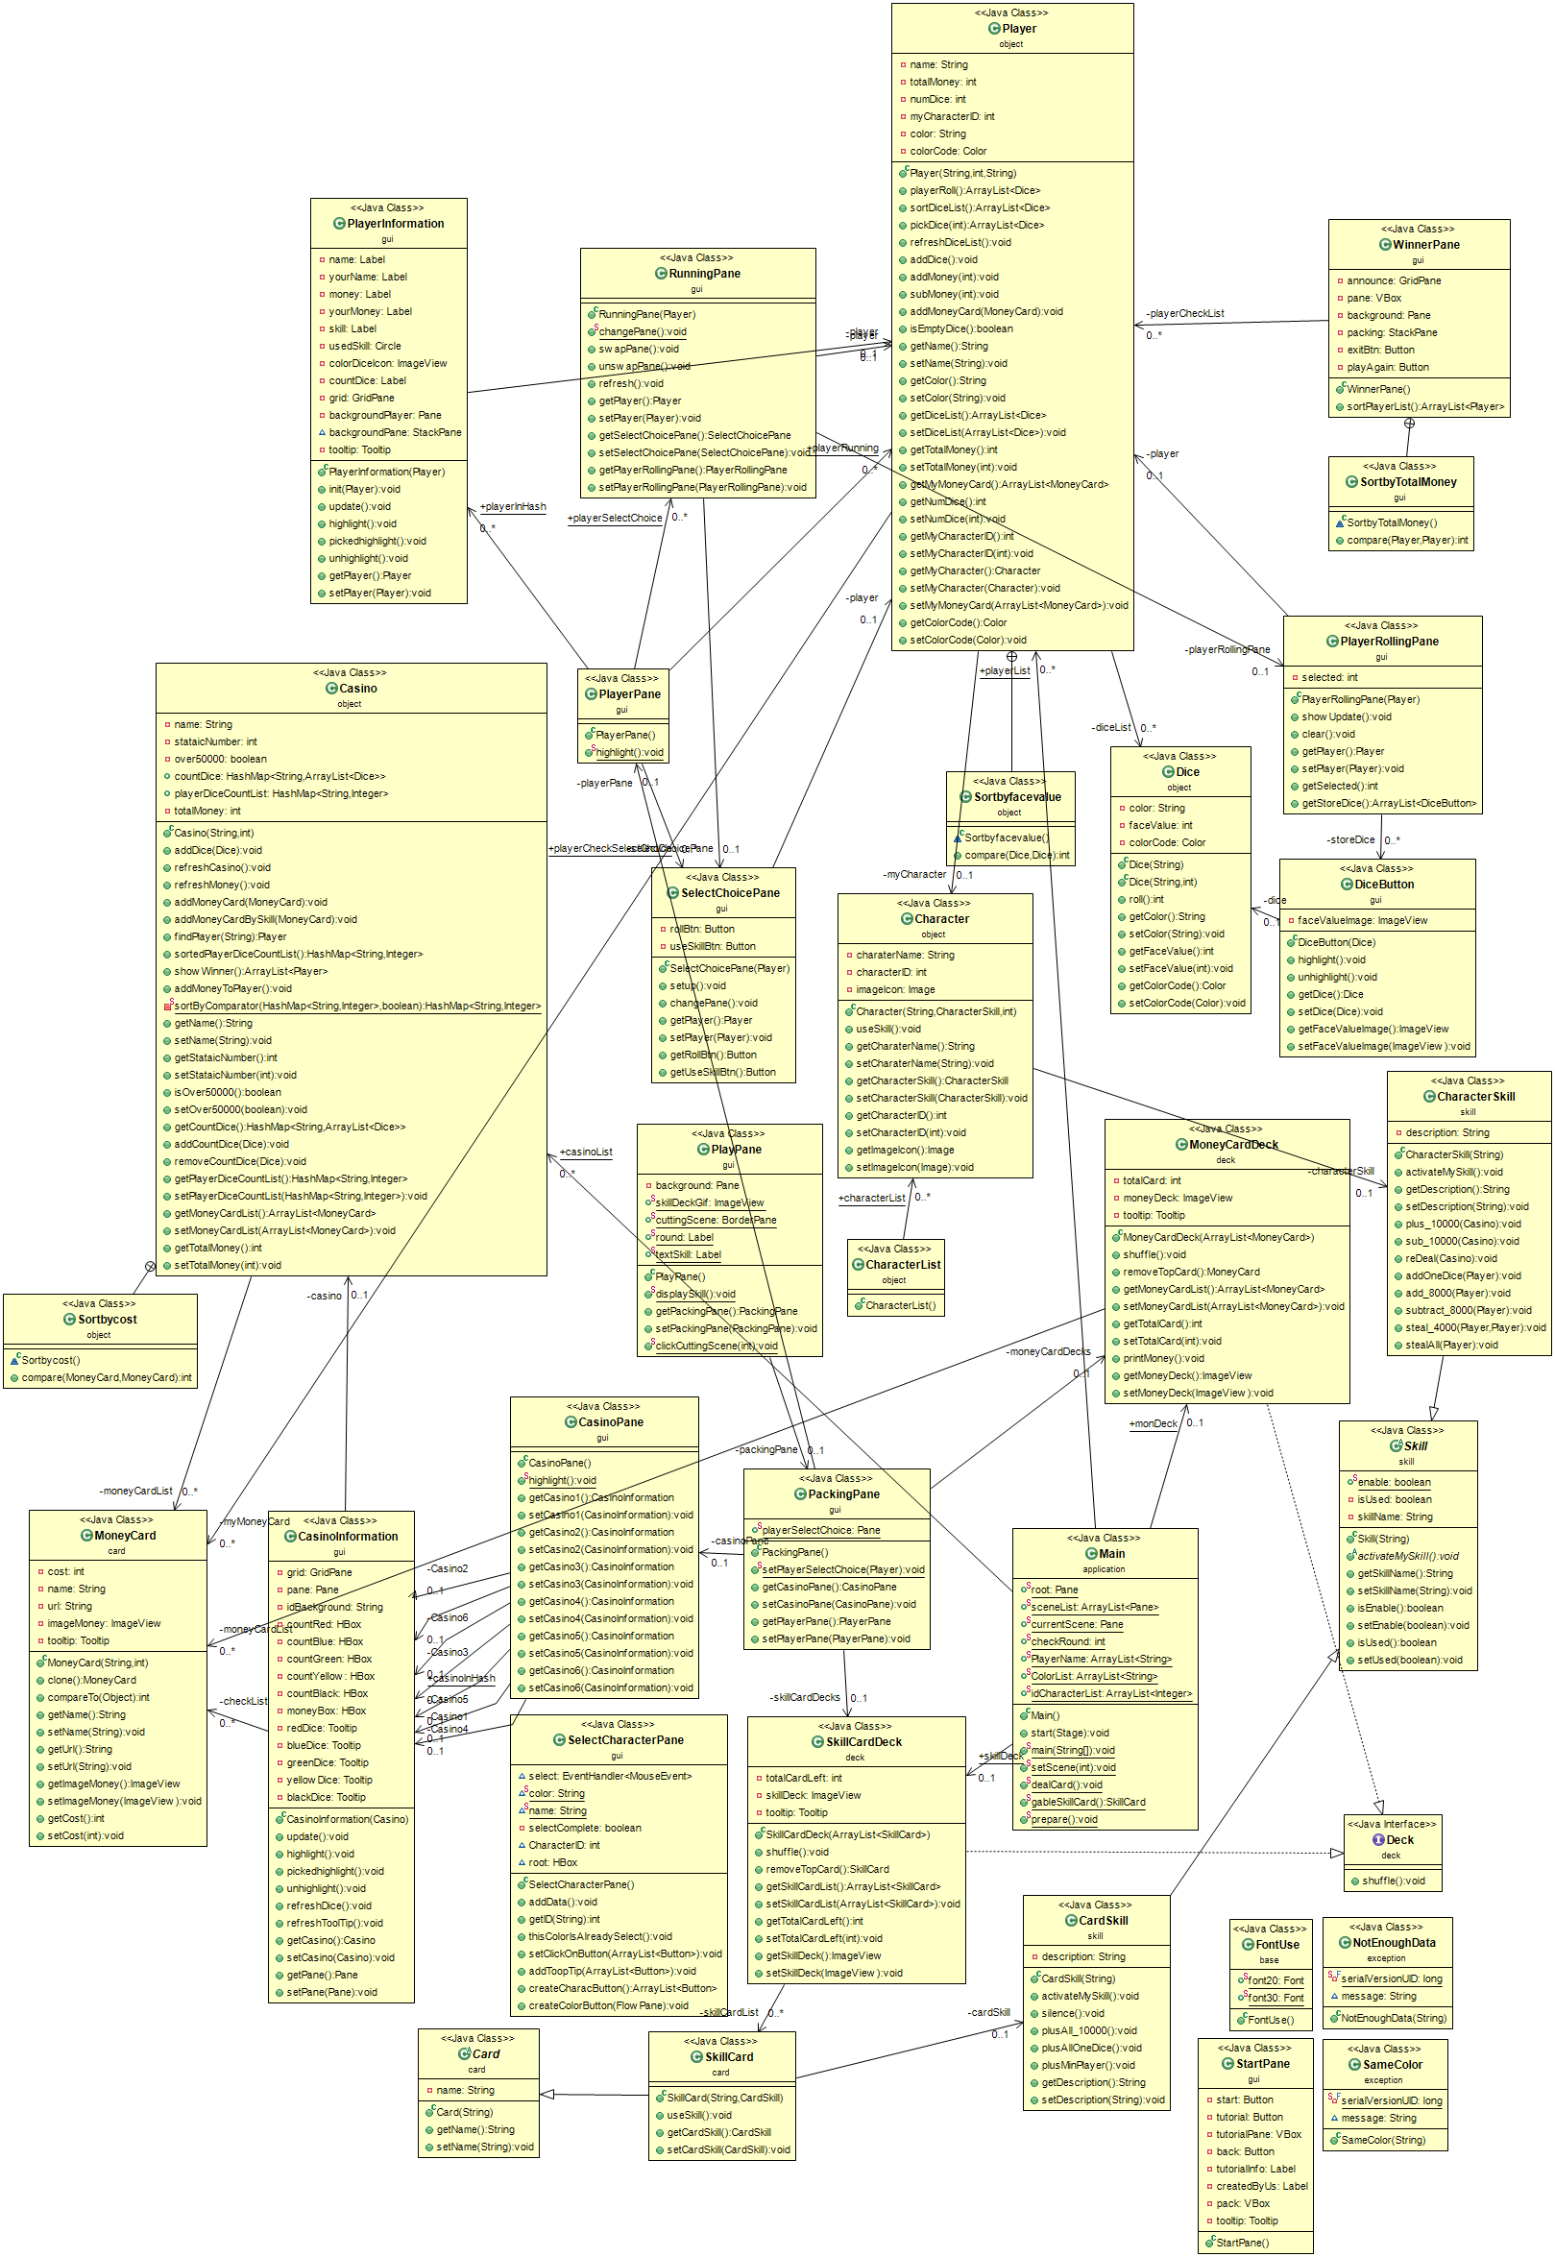**Class Diagram**

***+ (public)***

***# (protected)***

***- (private)***

***static*** *will be underlined.*

***abstract*** *will be italic*

**1.Package skill**

This package contains skills which is used in the game

* 1. abstract class Skill

This class is the base of skills in character and card

1.1.1 Fields

|  |  |
| --- | --- |
| + boolean enable | that skill can be used or not |
| - boolean isUsed | is that skill has been used |
| - String skillName | skill name |

1.1.2 Constructor

|  |  |
| --- | --- |
| + Skill(String skillName) | -Construct Skill  -set skillName |

1.1.3 Methods

|  |  |
| --- | --- |
| *+ void activateMySkill()* | Use skill |
| generate getter and setter of fields |  |

* 1. class CardSkill extends Skill

This class is skill in a skill card.

1.2.1 Field

|  |  |
| --- | --- |
| - String description | the description of card skill |

1.2.2 Constructor

|  |  |
| --- | --- |
| + CardSkill(String skillname) | -create CardSkill with the skillname  -set description by skillname |

1.2.3 Methods

|  |  |
| --- | --- |
| + void activateMySkill() | call the skill methods below by this skillName |
| + void silence() | disable player’s character skill |
| + void plusAll_10000() | insert $10,000 card to casino |
| + void plusAllOneDice() | add a dice to each player dice list |
| + void plusMinPlayer() | add $10,000 to player with least money |
| generate getter and setter of field |  |

* 1. class CharacterSkill extends Skill

This class is skill in a character.

1.3.1 Field

|  |  |
| --- | --- |
| - String description | the description of character skill |

1.3.2 Constructor

|  |  |
| --- | --- |
| + CharacterSkill (String skillname) | -create CharacterSkill with the skillname  -set description by skillname |

1.3.3 Methods

|  |  |
| --- | --- |
| + void activateMySkill() | call the skill methods below by this skillName |
| + void plus_10000(Casino casino) | add $10,000 to highest moneyCard in casino |
| + void sub_10000(Casino casino) | reduce $10,000 to highest money card in casino |
| + void reDeal(Casino casino) | - call refreshMoney() in casino  - add moneyCards in moneyCardList to casino |
| + void addOneDice(Player p) | add one dice to player p’s diceList |
| + void add_8000(Player p) | add $8,000 to player p’s totalMoney |
| + void subtract_8000(Player p) | decrease player p’s totalMoney by $8,000 |
| + void steal_4000(Player self, Player target) | decrease player target’s totalMoney by $4,000 and add $4,000 to player self’s totalMoney |
| + void stealAll(Player self) | decrease other players totalMoney by $2,000 and add that to player self’s totalMoney |
| generate getter and setter of field |  |

**2. Package Card**

2.1 class MoneyCard implements Cloneable, Comparable<Object>

This class is money cards which use to add to casino and then add to player in the game.

2.1.1 Fields

|  |  |
| --- | --- |
| - int cost | cost of the MoneyCard |
| - String name | name of MoneyCard |
| - String url | String contains the location of MoneyCard’s image |
| - ImageView imageMoney | image of MoneyCard |
| - Tooltip tooltip | Tooltip of MoneyCard |

2.1.2 Constructor

|  |  |
| --- | --- |
| + MoneyCard(String name, int cost) | -create MoneyCard and set name and cost  -set url by name  -set imageMoney by url  -set tooltip to show the cost by enter the mouse and hide it when the mouse exit |

2.1.3 Methods

|  |  |
| --- | --- |
| + MoneyCard clone() | clone itself |
| + int compareTo(Object o) | compare MoneyCard to another by cost |
| generate getter and setter of fields |  |

2.2 class SkillCard

This class is a skill card that use to make events in the game in round 2,3,4,5.

2.2.1 Fields

|  |  |
| --- | --- |
| - String name | name of SkillCard |
| - CardSkill cardSkill | card skill of SkillCard |

2.2.2 Constructor

|  |  |
| --- | --- |
| +SkillCard(String name, CardSkill cardSkill) | create SkillCard and set name and cardSkill |

2.2.3 Methods

|  |  |
| --- | --- |
| +void useSkill() | call activateMySkill() from cardSkill |
| generate getter and setter of fields |  |

**3. Package Deck**

3.1 interface Deck

This interface contains method shuffle to shuffle cards in the deck

|  |  |
| --- | --- |
| + void shuffle(); | shuffle the deck |

3.2 class MoneyCardDeck implements Deck

This is a deck of money cards which use to distribute money to casino.

3.2.1 Fields

|  |  |
| --- | --- |
| - ArrayList<MoneyCard> moneyCardList | list of MoneyCard in deck |
| - int totalCard | total number of MoneyCard |
| - ImageView moneyDeck | image which is MoneyDeck.png |
| - Tooltip tooltip | tooltip |

3.2.2 Constructor

|  |  |
| --- | --- |
| + MoneyCardDeck(ArrayList<MoneyCard> cardList) | -create MoneyCardDeck  -set this moneyCardList  -set tooltip to show the number of cards left when the mouse enter and hide it when the mouse exit |

3.2.3 Methods

|  |  |
| --- | --- |
| + void shuffle() | shuffle moneyCardList |
| + MoneyCard removeTopCard() | -return first money card in moneyCardList  -decrease totalCard by 1  -update text in tooltip |
| generate getter and setter of fields |  |

**4. Package Object**

This package contains objects in the game which is Casino, Character, Character list, Player and Dice.

4.1 class Casino

This class is a Casino in the game which contains player dices and money cards. It will distribute money cards to the winner in casino at the end of each round.

4.1.1 Fields

|  |  |
| --- | --- |
| - String name | name of casino |
| - int stataicNumber | id of casino |
| - boolean over50000 | - to check that this casino have total money more than 50,000  -set false at the start |
| + HashMap<String, ArrayList<Dice>> countDice | list of dices in casino for each dice color |
| + HashMap<String, Integer> playerDiceCountList | number of dices in casino for each player’s dice color |
| - ArrayList<MoneyCard> moneyCardList | list of money card in casino |
| - int totalMoney | -total money in casino  -set 0 at the start |

4.1.2 Constructor

|  |  |
| --- | --- |
| + Casino(String name, int staticNumber) | -create casino and set name and stataic number  -add (“Red” , new ArrayList of dice) , (“Blue” , new ArrayList of dice) , (“Green” , new ArrayList of dice) , (“Black” , new ArrayList of dice) , (“Yellow” , new ArrayList of dice) to countDice  -add (“Red” , 0) , (“Blue” , 0 ) , (“Green” , 0) , (“Black” , 0) , (“Yellow” , 0) to playerDiceCountList |

4.1.3 Methods

|  |  |
| --- | --- |
| + void addDice(Dice d) | - add dice to the color with the same as dice color in countDice  - +1 to value in key with the same color in playerDiceCountList |
| + void refreshCasino() | -clear moneyCardList  -clear the value in countDice  -clear the value in playerDiceCountList  -set over50000 to false  -set totalMoney to 0 |
| + void refreshMoney() | -clear moneyCardList  - set over50000 to false  -set totalMoney to 0 |
| + void addMoneyCard(MoneyCard m) | - if casino not over50000 then add MoneyCard m  - if totalMoney exceeds 50000, Then set over50000 to true  -sort this moneyCardList |
| + void addMoneyCardBySkill(MoneyCard m) | -add MoneyCard m to moneyCardList  -add cost of MoneyCard m to totalMoney  -sort moneyCardList |
| + Player findPlayer(String color) | - return player with the same color |
| + HashMap<String, Integer> sortedPlayerDiceCountList() | - sort playerDiceCountList |
| + ArrayList<Player> showWinner() | - sort playerDiceCountList  - return the winner player in casino |
| + void addMoneyToPlayer() | - add money to the winner |
| - HashMap<String, Integer> sortByComparator(HashMap<String, Integer> unsortMap, final boolean order) | - Sorting the list based on values |
| generate getter and setter of fields |  |

4.1.4 class Sortbycost implements Comparator<MoneyCard> use to sort moneyCardList.

4.2 class Character

This class is a character in the game. It has different skills to use at the start of player’s turn.

4.2.1 Fields

|  |  |
| --- | --- |
| - String charaterName | name of character |
| - CharacterSkill characterSkill | character skill of character |
| - int characterID | id of character |
| - Image imageIcon | image of character |

4.2.2 Constructor

|  |  |
| --- | --- |
| + Character(String characterName, CharacterSkill characterSkill, int charaterID) | create new character and set character name , characterSkill, characterID. |

4.2.3 Methods

|  |  |
| --- | --- |
| - void useSkill() | call activateMySkill() from characterSkill |
| generate getter and setter of fields |  |

4.3 class CharacterList

This class contain an array of all characters.

4.3.1 Field

|  |  |
| --- | --- |
| + Character[] characterList | Array of all characters |

4.3.2 Constructor

|  |  |
| --- | --- |
| + CharacterList() | create CharacterList |

4.4 class Dice

This class is dice which you use to roll. There are 5 colors of dices which are red, yellow, blue, green and black.

4.4.1 Fields

|  |  |
| --- | --- |
| - String color | color of the dice in string |
| - int faceValue | - number on the dice face  - set 0 at the start |
| - Color colorCode | color of the dice |

4.4.2 Constructor

|  |  |
| --- | --- |
| + Dice(String color) | -create dice  -set color and set colorCode by color |

4.4.3 Methods

|  |  |
| --- | --- |
| + int roll() | - return a random int between 1-6 |
| generate getter and setter of fields |  |

4.4 class Player

This class is player in the game. Player has a character chosen before the game start. Player can choose to use skill from his character or roll the dice at the start of his turn. If player roll a dice, he needs to choose one number on the dice’s face. Those dices with the same face as selected one will goes to the casino with the same value.

4.4.1 Fields

|  |  |
| --- | --- |
| - String name | name of player |
| - ArrayList<Dice> diceList | player’s dice list |
| - int totalMoney | -total money  -set to 0 |
| - int numDice | -number of total dice  -set to 8 |
| - int myCharacterID | - player’s character id |
| - Character myCharacter | - player’s character |
| - String color | - player dice color |
| - ArrayList<MoneyCard> myMoneyCard | - player’s list of money card |
| - Color colorCode | - color code |

4.4.2 Constructor

|  |  |
| --- | --- |
| + Player(String name, int myCharacterID, String color) | -create new player and set name, myCharacterID , color  -set colorCode by color  -set myCharacter by character id  -add dices to dice list numDice times |

4.4.3 Methods

|  |  |
| --- | --- |
| + ArrayList<Dice> playerRoll() | - roll the dices in diceList  -return diceList |
| + public ArrayList<Dice> sortDiceList() | sort diceList |
| + ArrayList<Dice> pickDice(int diceNum) | - remove dices which face value equals to diceNum from diceList  - return list of dices which face value equals to diceNum. |
| + void refreshDiceList() | if this diceList is empty  - set numDice to 8  - add dices to list numDice times |
| + void addDice() | add one dice to player |
| + void addMoney(int i) | plus i to totalMoney |
| + void subMoney(int i) | substract i from totalMoney |
| + addMoneyCard(MoneyCard m) | add MoneyCard m to myMoneyCard |
| + boolean isEmptyDice() | check that is diceList empty or not |
| generate getter and setter of fields |  |

4.4.4 class Sortbyfacevalue implements Comparator<Dice> to compare dice by number of face value.

**5. Package exception**

This class contains exceptions when players choose their character

5.1 class NotEnoughData extends Exception

This class is an exception occur when player doesn’t enter name or color.

5.1.1 Field

|  |  |
| --- | --- |
| - final long serialversionUID | 1L |
| + String message | cause of the error |

5.1.2 Constructor

|  |  |
| --- | --- |
| + NotEnoughData(String message) | - create warning window containing message |

5.2 class SameColor extends Exception

This class is an exception occur when player choose the color that has been picked.

5.2.1 Field

|  |  |
| --- | --- |
| - final long serialversionUID | 2210358159147034672L |
| + String message | cause of the error |

5.2.2 Constructor

|  |  |
| --- | --- |
| + SameColor(String message) | - create warning window containing message |

**6. Package base**

This package’s contain base to create user interface such as font, sound

6.1 Class FontUse

Contain font which usually used.

6.1.1 Field

|  |  |
| --- | --- |
| + Font font20 | Font QuiteMagicalRegular-8VA2 sizes 20. |
| + Font font30 | Font QuiteMagicalRegular-8VA2 sizes 30. |
| + Font font40 | Font QuiteMagicalRegular-8VA2 sizes 40. |
| + Font font70 | Font QuiteMagicalRegular-8VA2 sizes 70. |
| + Font font80 | Font QuiteMagicalRegular-8VA2 sizes 80. |
| + Font font120 | Font QuiteMagicalRegular-8VA2 sizes 120. |

6.2 Class SoundUse

Contain sound which usually used.

6.2.1 Field

|  |  |
| --- | --- |
| + mouseClick | Sound of mouse click. |
| + mouseEnter | Sound of mouse enter. |
| + mouseEnterDice | Sound of mouse enter to dice. |
| + rollDice | Sound of rolling dice. |
| + dealSkillCard | Sound of dealing skill card. |
| + diceClick | Sound of clicking dice. |
| + useSkill | Sound of using skill. |
| + startSound | Background Sound while starting. |
| + playingSound | Background Sound while playing . |
| + endingSound | Background Sound while ending. |

6.2.2 Constructor

|  |  |
| --- | --- |
| + SoundUse() | Set all field’s volume to 0.3 except .  startSound set to 0.2.  endingSound set to 0.5. |

**7. package gui**

This package’s contain all of user interface to run this game.

7.1 Class CasinoInformation extends StackPane

This class is pane which contain information of their own casino to update and alert your item in that casino

7.1.1 Field

|  |  |
| --- | --- |
| - Casino casino | Set casino to this pane. |
| - GridPane grid | To be added by information. |
| - Pane pane | Be a background of this class. |
| - String idBackground | String of id background. |
| - Hbox countRed | To be added by red dice. |
| - Hbox countBlue | To be added by blue dice. |
| - Hbox countGreen | To be added by green dice. |
| - Hbox countYellow | To be added by yellow dice. |
| - Hbox countBlack | To be added by black dice. |
| - Hbox moneyBox | To be added by money card. |
| - ArrayList<MoneyCard> checkList | List of money card to check if casino has change in money list. |
| - Tooltip redDice | To show number of red dice in this casino. |
| - Tooltip blueDice | To show number of blue dice in this casino. |
| - Tooltip greenDice | To show number of green dice in this casino. |
| - Tooltip yellowDice | To show number of yellow dice in this casino. |
| - Tooltip blackDice | To show number of black dice in this casino. |

7.1.2 Constructor

|  |  |
| --- | --- |
| + CasinoInformation(Casino casino) | - Set casino to this pane and set background of this pane by using idBackground. Set checkList equal to casino money card list.  - Create image view for each color and add tooltip to show number of dice in this casino.  - Create moneyIcon by image view.  - Add image view, moneyIcon, moneyBox and countRed, countBlue, countGreen, countYellow, countBlack to grid to show information. |

7.1.3 Methods

|  |  |
| --- | --- |
| + void update() | To update all of information in this casino that have changed. |
| + void highlight() | Highlight with gold color. |
| + void pickedhighlight() | Highlight with red color. |
| + void unhighlight() | Unhighlight. |
| + void refreshDice() | To clear and add dice in countDice in order to update. |
| + void refreshToolTip() | Set tooltip to show current amount of dices. |
| + setters and getter for each field as needed |  |

7.2 Class CasinoPane extends Hbox

This class is pane that pack the casinoInformation to add to PlayPane.

7.2.1 Field

|  |  |
| --- | --- |
| - CasinoInformation casino1 | Construct with casino number 1 |
| - CasinoInformation casino2 | Construct with casino number 2 |
| - CasinoInformation casino3 | Construct with casino number 3 |
| - CasinoInformation casino4 | Construct with casino number 4 |
| - CasinoInformation casino5 | Construct with casino number 5 |
| - CasinoInformation casino6 | Construct with casino number 6 |
| + HashMap<Casino, CasinoInformation> casinoInHash | Map which key is Casino and value is CasinoInformation. |

7.2.2 Constructor

|  |  |
| --- | --- |
| + CasinoPane() | Add all casino to casinoInHash and add to this pane. |

7.2.3 Methods

|  |  |
| --- | --- |
| + void highlight | Highlight all casinoInformation with gold color but only mouse enter get it red color. |
| + setters and getter for each field as needed |  |

7.3 Class PlayerInformation extends StackPane

This class is pane which contain information of their own casino to update and alert your item in that casino

7.3.1 Field

|  |  |
| --- | --- |
| - Player player | Set player to this pane. |
| - Label name | Label with text “Name :” |
| - Label yourName | Show your name. |
| - Label money | Label with text “Money :” |
| - Label yourMoney | Show your name. |
| - Label skill | Label with text “Skill :” |
| - Label countDice | Show your size of dice list. |
| - Circle usedSkill | Show that have you activated skill yet. |
| - ImageView colorCiceIcon | Image view of icon dice. |
| - GridPane grid | To pack all label together. |
| - Pane backgroundPlayer | Background of player. |
| - StackPane backgroundPane | Background of this pane. |
| - Tooltip tooltip | To show skill description. |

7.3.2 Constructor

|  |  |
| --- | --- |
| + PlayerInformation(Player player) | - set player to this pane and add all label and circle to grid to display information of player and set tooltip at skill to display skill description. |

7.3.3 Methods

|  |  |
| --- | --- |
| + void update() | To update all of information in this player that have changed. |
| + void init(Player player) | Initial Player to thia pane and set background of this pane |
| + void highlight() | Highlight with gold color. |
| + void pickedhighlight() | Highlight with red color. |
| + void unhighlight() | Unhighlight. |
| + setters and getter for each field as needed |  |

7.4 Class PlayerPane extends Hbox

This class is pane that pack the PlayerInformation to add to PlayPane.

7.4.1 Field

|  |  |
| --- | --- |
| + HashMap<Player PlayerInformation> playerInHash | Map which key is Player and value is PlayerInformation. |
| + HashMap<Player, RunningPane> playerSelectChoice | Map which key is Player and value is RunningPane. |
| + HashMap<Player, SelectChoicePane> playerCheckSelectChoice | Map which key is Player and value is SelectChoicePane. |
| + ArrayList<Player> playerRunning | Contain list of player. |

7.4.2 Constructor

|  |  |
| --- | --- |
| + PlayerPane() | Add all player from Main to playerInHash, playerSelectChoicev, playerCheckSelectChoice, playerRunning |

7.4.3 Methods

|  |  |
| --- | --- |
| + void highlight | Highlight all playerInformation with gold color but only mouse enter get it red color. |
| + setters and getter for each field as needed |  |

7.5 Class DiceButton extends Button

This class is button that use after player roll then picked and add to casino.

7.5.1 Field

|  |  |
| --- | --- |
| - Dice dice | Set dice to this button. |
| - ImageView faceValueImage | Refer to facevalue of dice after roll. |

7.5.2 Constructor

|  |  |
| --- | --- |
| + DiceButton(Dice dice) | Set dice to this button and set facevalue image equal to facevalue of dice. |

7.5.3 Methods

|  |  |
| --- | --- |
| + void highlight | Highlight with gold color. |
| + void unhighlight | Unhighlight. |
| + setters and getter for each field as needed |  |

7.6 Class PlayerRollingPane extends HBox

This class is pane that display box of dice button after roll for each player.

7.6.1 Field

|  |  |
| --- | --- |
| - Player player | Set player to this pane. |
| - ArrayList<DiceButton> storeDice | Store the dice which be rolled. |
| - int selected | Facevalue of selected one. |

7.6.2 Constructor

|  |  |
| --- | --- |
| + PlayerRollingPane(Player player) | - Set player to this pane  - Set alignment to center and preference size to (800, 185). |

7.6.3 Methods

|  |  |
| --- | --- |
| + void showUpdate() | Clear this pane and add all rolled dice button to this pane to show. |
| + void clear() | Remove all dice from this pane and storeDice. |
| + setters and getter for each field as needed |  |

7.7 Class SelectChoicePane extends VBox

This class is pane that display box of two button that you can choose one of them to do their function. First is roll and another one is using skill.

7.7.1 Field

|  |  |
| --- | --- |
| - Player player | Set player to this pane. |
| - Button rollBtn | Rolling button. |
| - Button useSkillBtn | Use skill button. |

7.7.2 Constructor

|  |  |
| --- | --- |
| + SelectChoicePane(Player player) | - Set player to this pane  Set alignment to center and preference size to (800, 185).  - Add rollBtn and useSkillBtn to this pane and set on mouse enter and exit to set opacity of them and background of these two will be a color of player. |

7.7.3 Methods

|  |  |
| --- | --- |
| + void setup() | Refer to Skill. If skill is enable, useSkillBtn will enable to use. If not, useSkillBtn will be disabled. |
| + void changePane() | Remove useSkillBtn from this pane. |
| + setters and getter for each field as needed |  |

7.8 Class RunnigPane extends StackPane

This class is pane that running the process of this game.

7.8.1 Field

|  |  |
| --- | --- |
| - Player player | Set player to this pane. |
| - SelectChoicePane selectChoicePane | SelectChoicePane of this player. |
| - PlayerRollingPane playerRollingPane | PlayerRollingPane of this palyer. |

7.8.2 Constructor

|  |  |
| --- | --- |
| + RunningPane(Player player) | - Construct SelectChoicePane and PlayerRollingPane by player and add it into this pane and call method dealCard from Main to deal money card to Casino.  - Set on mouse click with rollBtn and useSkillBtn, In case of rollBtn, It will automatically call swap method and roll method and display PlayerRollingPane and after select the dice, PlayerRollingPane will be swap to SelectChoicePane of next player by unswap method and changePane method. In another case, Character skill will be activated and set disable. Finally, make an update to player. |

7.8.3 Methods

|  |  |
| --- | --- |
| + void changePane() | - Use to change player after previous one roll and pick or use skill.  - Check if every player don’t have any dice and play next round.  - Check if this game is at the end and chage pane to WinnerPane. |
| + void swapPane() | Make SelectChoicePane disble and PlayerRollingPane visible and enable. |
| + void unswapPane() | Make SelectChoicePane enble and PlayerRollingPane invisible and disable. |
| + setters and getter for each field as needed |  |

7.9 Class PackingPane extends BorderPane

This class is pane that pack every pane together in order to run easily.

7.9.1 Field

|  |  |
| --- | --- |
| + Pane playerSelectChoice | Use to change player. |
| - CasinoPane casinoPane | An instance of CasinoPane |
| - PlayerPane playerPane | An instance of PlayerPane |
| - MoneyCardDeck moneyCardDeck | Set moneyCardDeck equal to Main.monDeck |
| - SkillCardDeck skillCardDeck | Set skillCardDeck equal to Main.skillDeck |

7.9.2 Constructor

|  |  |
| --- | --- |
| + PackingPane(Player player) | - Construct pane to add moneyCardDeck and pane to add skillCardDeck in order to set background with their image.  - Packing all of these which set left as a moneyCardDeck, set right as a skillCardDeck, set bottom as a playerPane, set top as a casinoPane, set center as a playerSelectChoice. |

7.9.3 Methods

|  |  |
| --- | --- |
| + void setPlayerSelectChoice(Player player) | Set playerSelectChoice with a runningPane of player in parameter. |
| + setters and getter for each field as needed |  |

7.10 Class StartPane extends StackPane

This class is the first pane that you can see in this game. It just a main menu which contain start button, tutorial button and credit.

7.10.1 Field

|  |  |
| --- | --- |
| - Button start | Button to start the game with text “Start”. |
| - Button tutorial | Button to read the tutorial with text “Tutorial”. |
| - Vbox tutorialPane | Pane which contain tutorial information and back button. |
| - Label tutorialInfo | Tutorial information. |
| - Button back | Button to go back to start pane with text “Back”. |
| - Label createdByUs | Credit of us with text “Created by PogUMeth”. |
| - Tooltip tooltip | Set to show our name. |
| - Vbox pack | Pane use to pack start button, tutorial button and createdByUs. |

7.10.2 Constructor

|  |  |
| --- | --- |
| + StartPane() | Create StartPane which have option below  - play the start sound.  - set this pane size to (1200, 675) and set background with background image.  - set tooltip with contain our name and set font to font30. Set this on mouse move to show text and mouse exit to hide tooltip.  - set up start if click will go to select character pane. If mouse enter, will set opacity to 1 but when it exit, return to default.  - set up tutorial if click will go to tutorial pane. If mouse enter, will set opacity to 1 but when it exit, return to default.  - set up createdByUs with font30, size (300, 50), opacity with 0.50, text fill with white color and set alignment to center.  - set spacing of pack to 30 and alignment to center then add start, tutorial and createdByUs.  - set tutorialInfo which contain information of tutorial.  - set up back button if click, get back to start pane. If mouse enter, will set opacity to 1 but when it exit, return to default.  - add tutorial information and back button to tutorial pane. |

7.11 Class SelectCharacterPane extends Hbox

This class is pane that you can select the character to use in this game. It just a pane which contain start button and alert confirmation.

7.11.1 Field

|  |  |
| --- | --- |
| - EventHandler<MouseEvent> select | Event of mouse. |
| - String color | To contain color. |
| - String name | To contain name. |
| - boolean selectComplete | To check that select pane is complete. |
| - int CharacterID | To contain CharacterID. |
| - Hbox root | Background of this pane. |

7.11.2 Constructor

|  |  |
| --- | --- |
| + SelectCharacterPane() | Set the pane to have you fill your information and contain with name, color. When confirm, it will add your information to Main. Finally, when already pick 5 character, it will constuct player and set Main scene to PlayPane |

7.11.3 Methods

|  |  |
| --- | --- |
| + void addData() throws NotEnoughData, SameColor | Add data to main if select all option in this pane. If not, throw exception. |
| + int getID(String id) | To return id character. |
| + void thisColorIsAlreadySelect() | When select the selected color, it will pop up that this color is already selected. |
| + void setClickOnButton(ArrayList<Button> buttonList) | Set the selected character button to disable. |
| + void addToolTip(ArrayList<Button> btnList) | Set tooltip to show character skill when mouse move into the button and hide when exit. |
| + ArrayList<Button> createCharacButton() | Create 8 character to 8 character button and set graphic then add to root. |
| + void createColorButton(FlowPane root) | Create color button which have red, green, blue, yellow and black color then set style and set on mouse click to trigger method thisColoeIsAlreadySelect. |

7.12 Class PlayPane extends StackPane

This class is pane that you can call to play the game.

7.12.1 Field

|  |  |
| --- | --- |
| - Pane background | Background of this pane. |
| - PackingPane packingPane | An instance of PackingPane. |
| + ImageView skillDeckGif | Image to draw a card. |
| + BorderPane cuttingScene | Use to show round. |
| + Label round | Use to check round. |
| + Label textSkill | Show skill information. |

7.12.2 Constructor

|  |  |
| --- | --- |
| + PlayPane() | - Set sound playingPane.play()  - Set textskill disable and opacity 0.  - Set cuttingScene at center with round and create label click with text “Click to continue” and set at the bottom of cuttingScene.  - Set background.  - Set textfill and font to all label and add all into this pane.  - Call method clickCuttingScene(1) to start the game.  - Set on mouse click on skillDeckGif to draw and activate skill then fade out.  - Set on mouse click on textSkill to fade out. |

7.12.3 Methods

|  |  |
| --- | --- |
| + void displaySkill() | Use to fade in skillDeckGif and set enable. |
| + void clickCuttingScene(int i) | Use to cut scene when new round and call method displaySkill if it is’t first round. |
| + setters and getter for each field as needed |  |

7.13 Class WinnrePane extends StackPane

This class is pane that show the winner and have a exit button and play again button

7.13.1 Field

|  |  |
| --- | --- |
| - ArrayList<Player> playerCheckList | Same as Main.playerList. |
| - GridPane announce | Announce board. |
| - VBox pane | Pack the announcement and announce board. |
| - Pane background | Background of this pane. |
| - StackPane packing | Packing all of these. |
| - Button exitBtn | To exit program. |
| - Button playAgain | To play again. |

7.13.2 Constructor

|  |  |
| --- | --- |
| + WinnerPane() | - Set sound endingPane.play()  - Set background.  - Sort playerlist and add to announce by order and add exitBtn and playAgain which set on mouse click to do their own function.  - Create label announcement to be a title of announce board.  - Set image to announce and add announcement and anounce board to pane(VBox)  - Add background and pane(VBox) to packing and then add packing to this pane. |

7.13.3 Methods

|  |  |
| --- | --- |
| + ArrayList<Player> sortPlayerList() | Sort the playerlist. |

7.13.4 Class SortbyTotalMoney implements Comparator<Player> to sort player by totalmoney

**8. package application**

This package’s contain only Main to launch application

8.1 Class Main

8.1.1 Field

|  |  |
| --- | --- |
| + Pane root | This will be scene of application. |
| + ArrayList<Pane> sceneList | Contain all pane that use. |
| + Pane currentScene | Current pane. |
| + int checkRound | Check round of game. |
| + ArrayList<String> PlayerName | List of PlayerName. |
| + ArrayList<String> ColorList | List of Color. |
| + ArrayList<Integer> idCharacterList | List of idCharacter. |
| + ArrayList<Casino> casinoList | List of Casino. |
| + ArrayList<Player> playerList | List of Player. |
| + MoneyCardDeck monDeck | An instance of MoneyCardDeck. |
| + SkillCardDeck skillDeck | An instance of SkillCardDeck. |

8.1.2 Methods

|  |  |
| --- | --- |
| + void start(Stage stage) | - Call method prepare to prepare for construct all object.  - Construct StartPane and SelectCharacterPane then add to sceneList.  - Set root size(1200, 675) and add start to root.  - Set root to scene and show the stage. |
| + void main(String[] args) | Application launch. |
| + void setScene(int index) | Set scene by sceneList at index then set the previous one invisible. |
| + void dealCard() | Deal card from moneyCardDeck and to all Casino. |
| + SkillCard gableSkillCard() | Draw the top of skillCardDeck and activate it. |
| + void prepare() | Construct moneyCardDeck and skillCardDeck and Casino. |